

**FUNDAMENTAL OF PROGRAMMING**

***LAB MANUAL 7***

**LAB TASKS**

**NAME :** Daniyal Ahmed

**CLASS :** ME-15

**SECTION :** B

**CMS ID :** 457165

**DATE:30/11/2023**

**TASK 1**

#include <bits/stdc++.h>

using namespace std;

int main()

{

cout<<"Enter length of array : ";

int n;

cin>>n;

int arr[n]={};

double sum;

cout<<"Enter the values of array : \n";

for(int i=0;i<n;++i){

cin>>arr[i];

}

for(int j=0;j<n;++j){

sum+=arr[j];

}

cout<<"The average of the following numbers is "<<sum/n;

return 0;

}

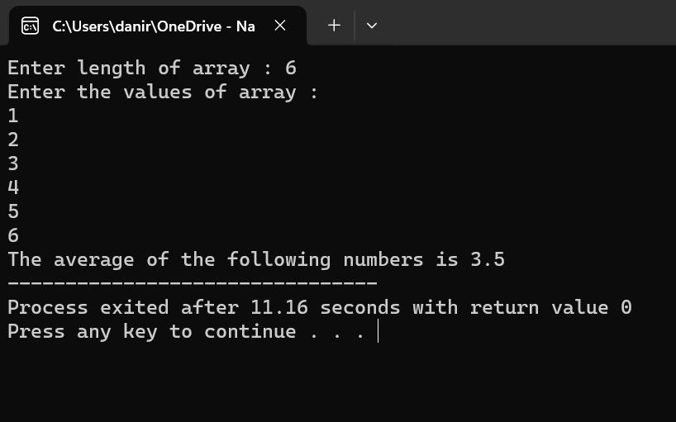

**TASK 2**

#include <bits/stdc++.h>

using namespace std;

int main()

{

int arr[5]={},min;

cout<<"Enter values of array : \n";

for(int i=0;i<5;++i){

cin>>arr[i];

}

cout<<"Values before sorting : \n";

for(int a=0;a<5;++a){

cout<<arr[a]<<"\t";

}

cout<<endl;

for(int i=0;i<5;++i){

for(int j=0;j<(5-1);++j){

if(arr[j]>arr[j+1]){

min = arr[j];

arr[j] = arr[j+1];

arr[j+1] = min;

}

}

}

cout<<"Values after sorting : \n";

for(int k=0;k<5;++k){

cout<<arr[k]<<"\t";

}

return 0;

}

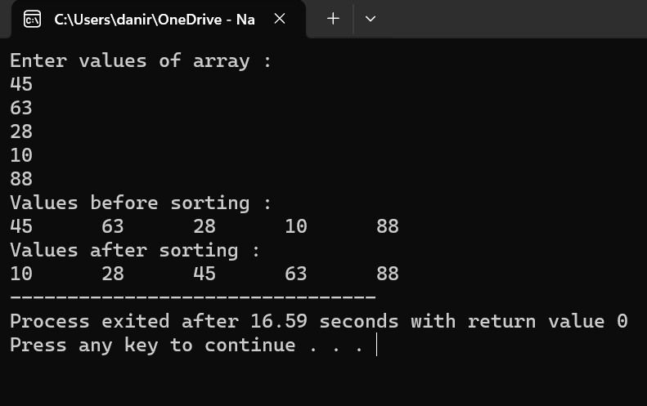

**TASK 3**

#include <bits/stdc++.h>

using namespace std;

int main()

{

int arr[5]={},min;

cout<<"Enter values of array : \n";

for(int i=0;i<5;++i){

cin>>arr[i];

}

cout<<"Values before sorting : \n";

for(int a=0;a<5;++a){

cout<<arr[a]<<"\t";

}

cout<<endl;

for (int i = 0; i<5; ++i){

min = arr[i];

for (int j = i; j < 5; ++j){

if (min > arr[j]){

min = arr[j];

arr[j] = arr[i];

arr[i] = min;

}

}

}

cout<<"Values after sorting : \n";

for(int k=0;k<5;++k){

cout<<arr[k]<<"\t";

}

return 0;

}

